CS 255 System Design Document Template
Bryan D. Rodriguez Perez

UML Diagrams

UML Use Case Diagram
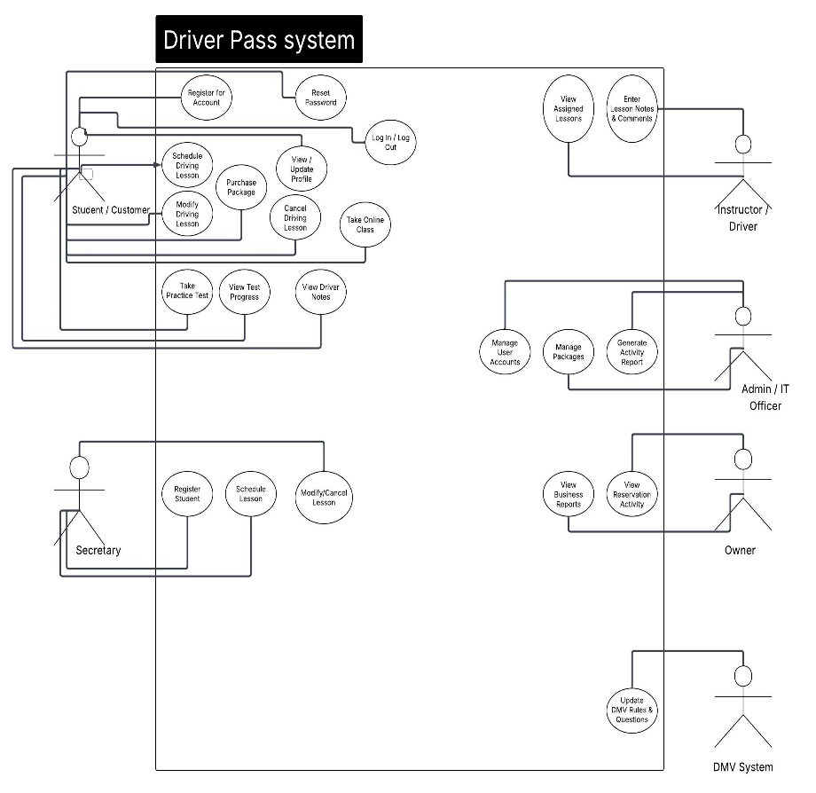

UML Activity Diagrams
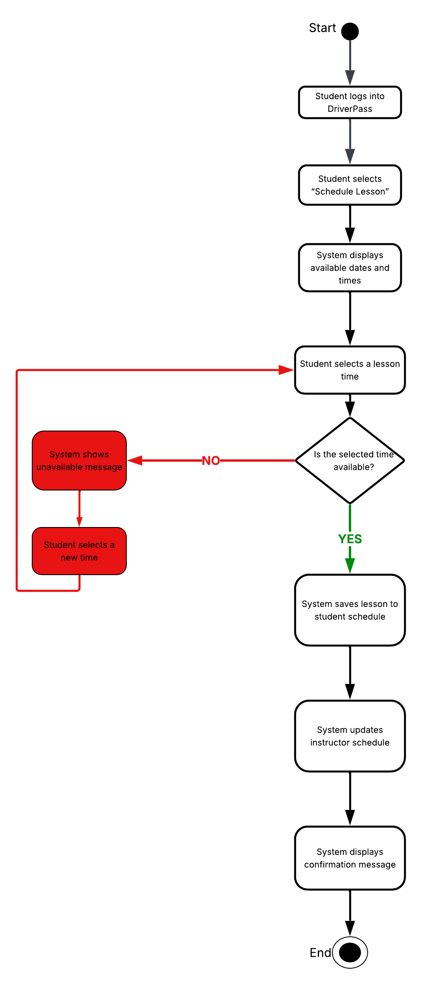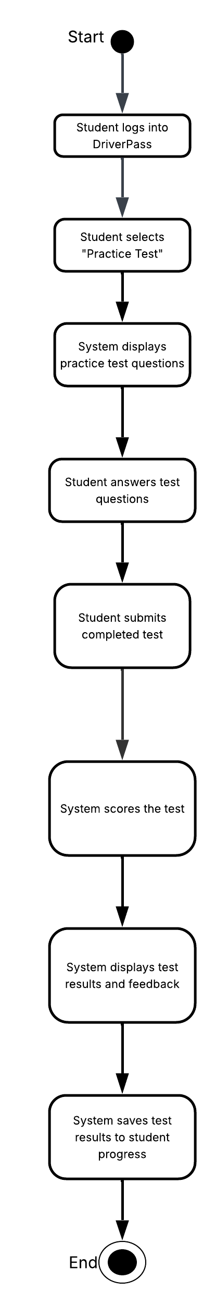

UML Sequence Diagram
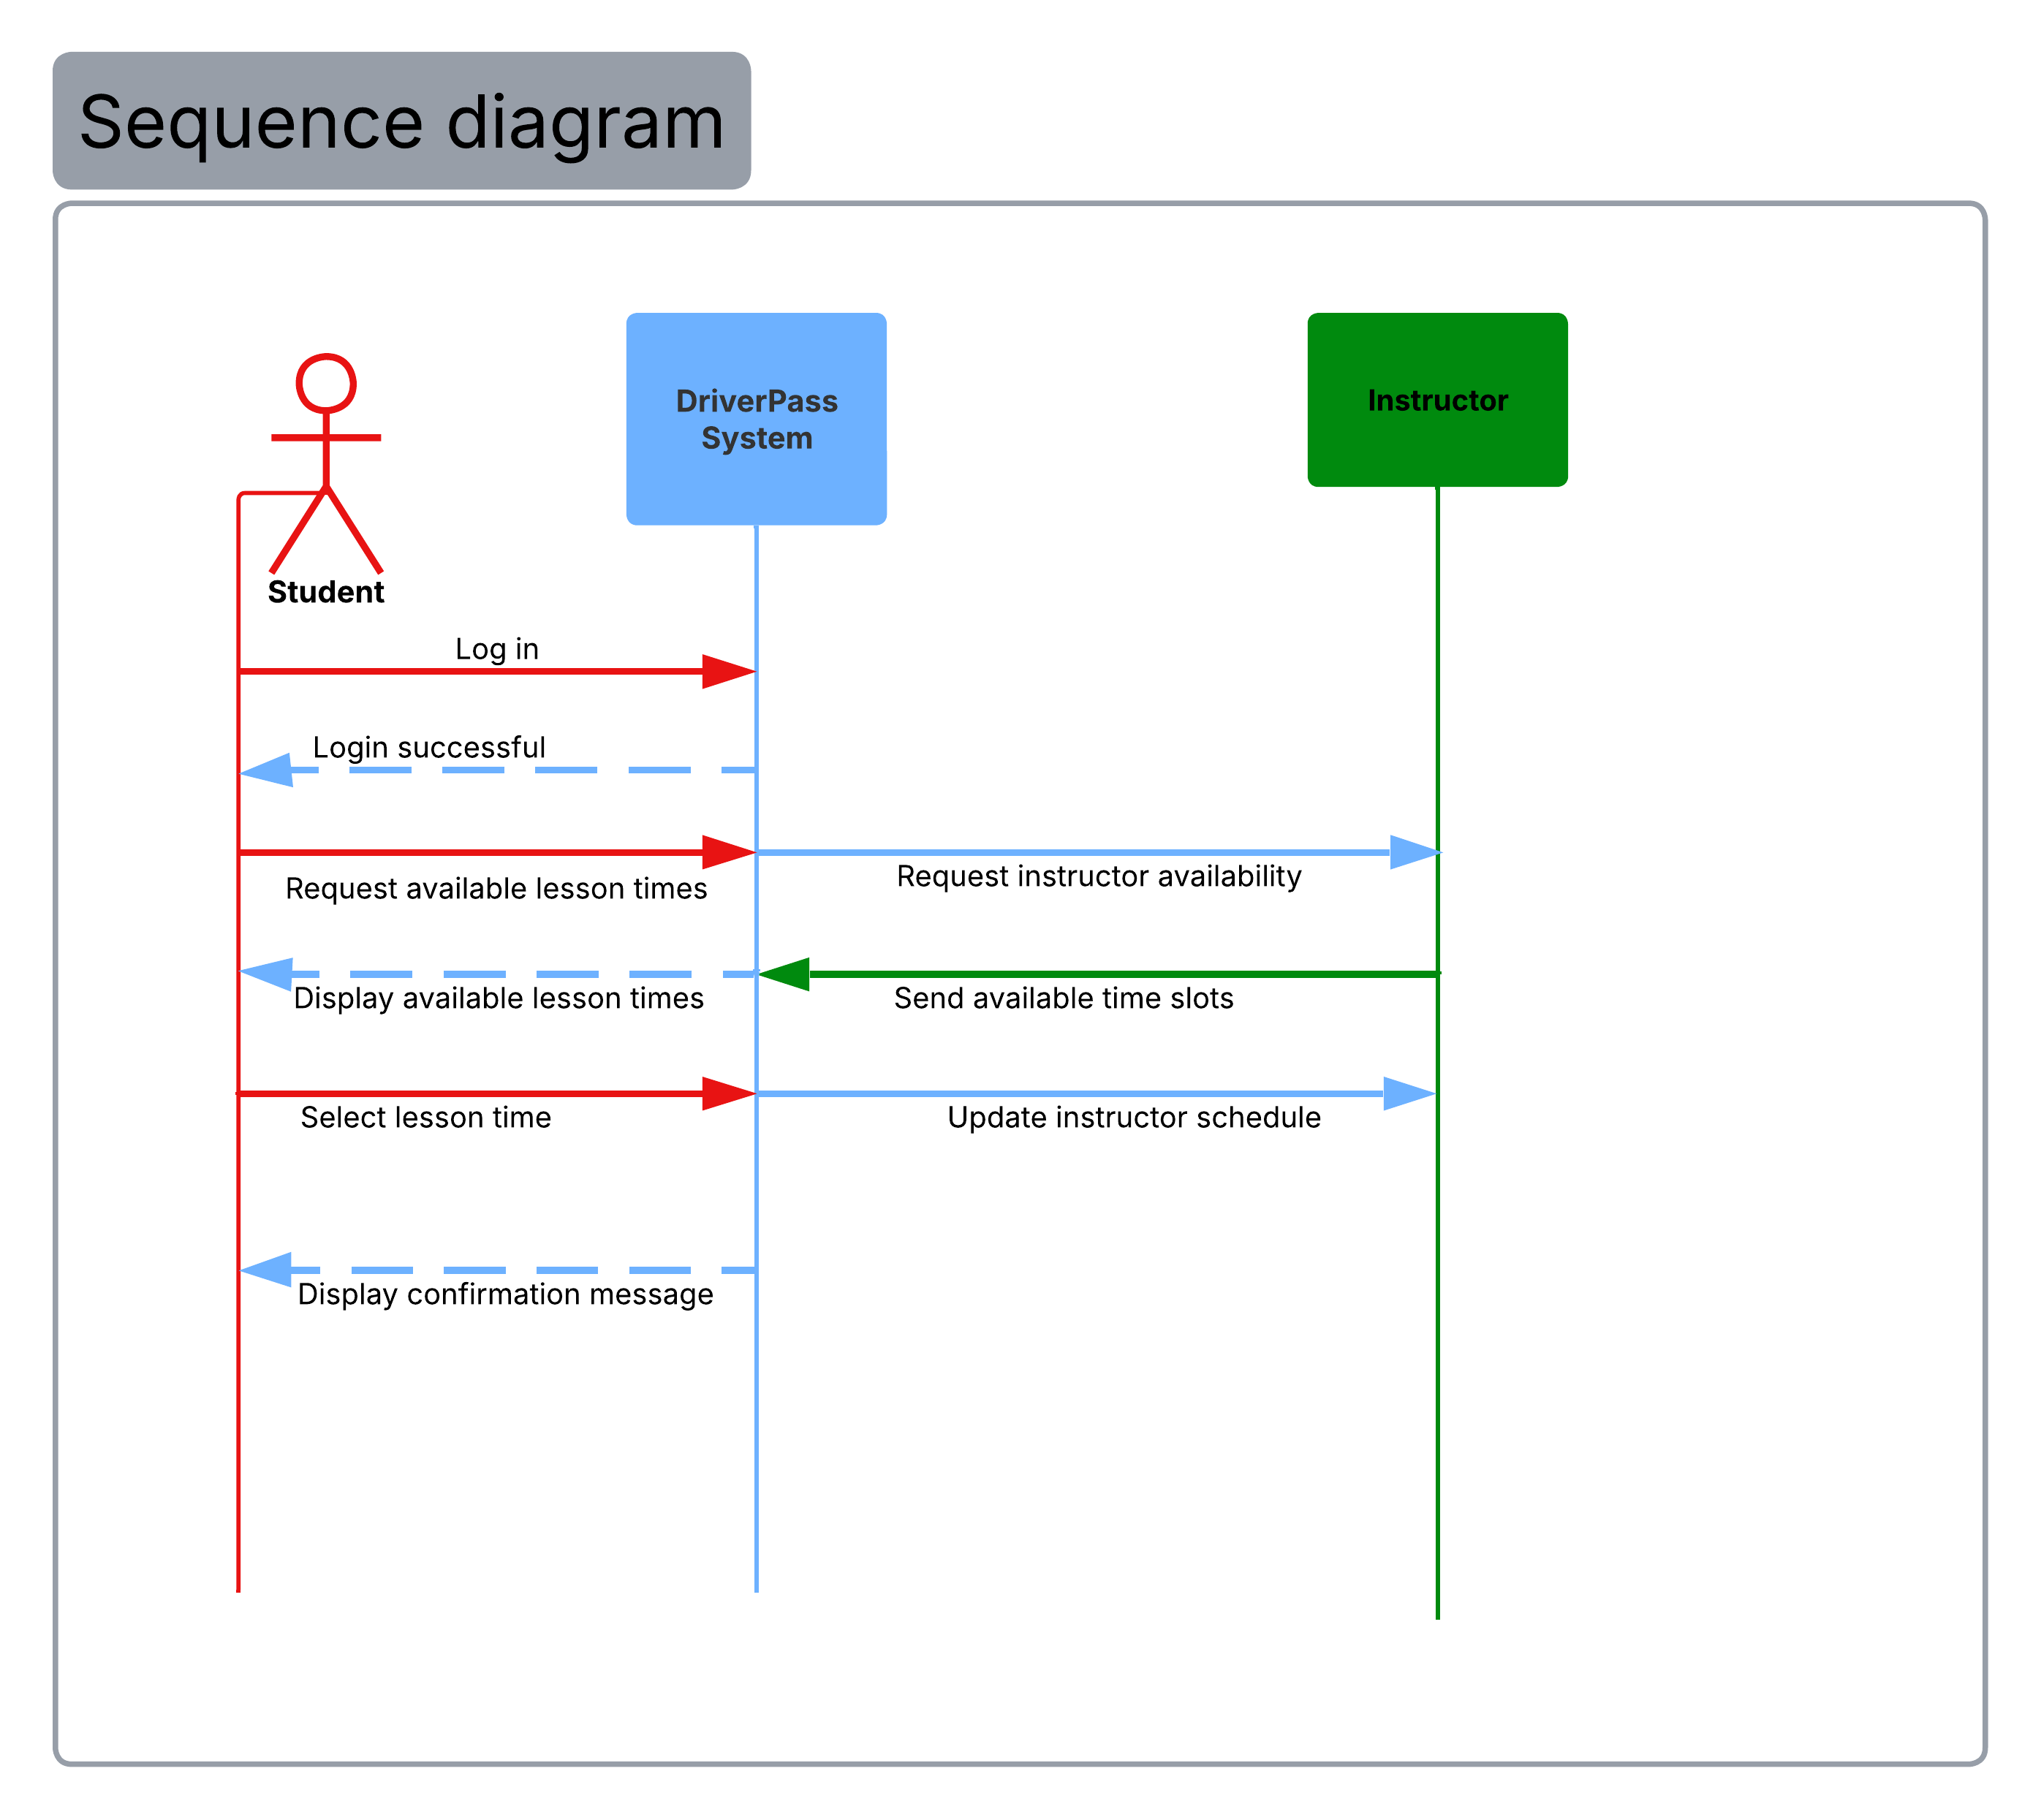

UML Class Diagram
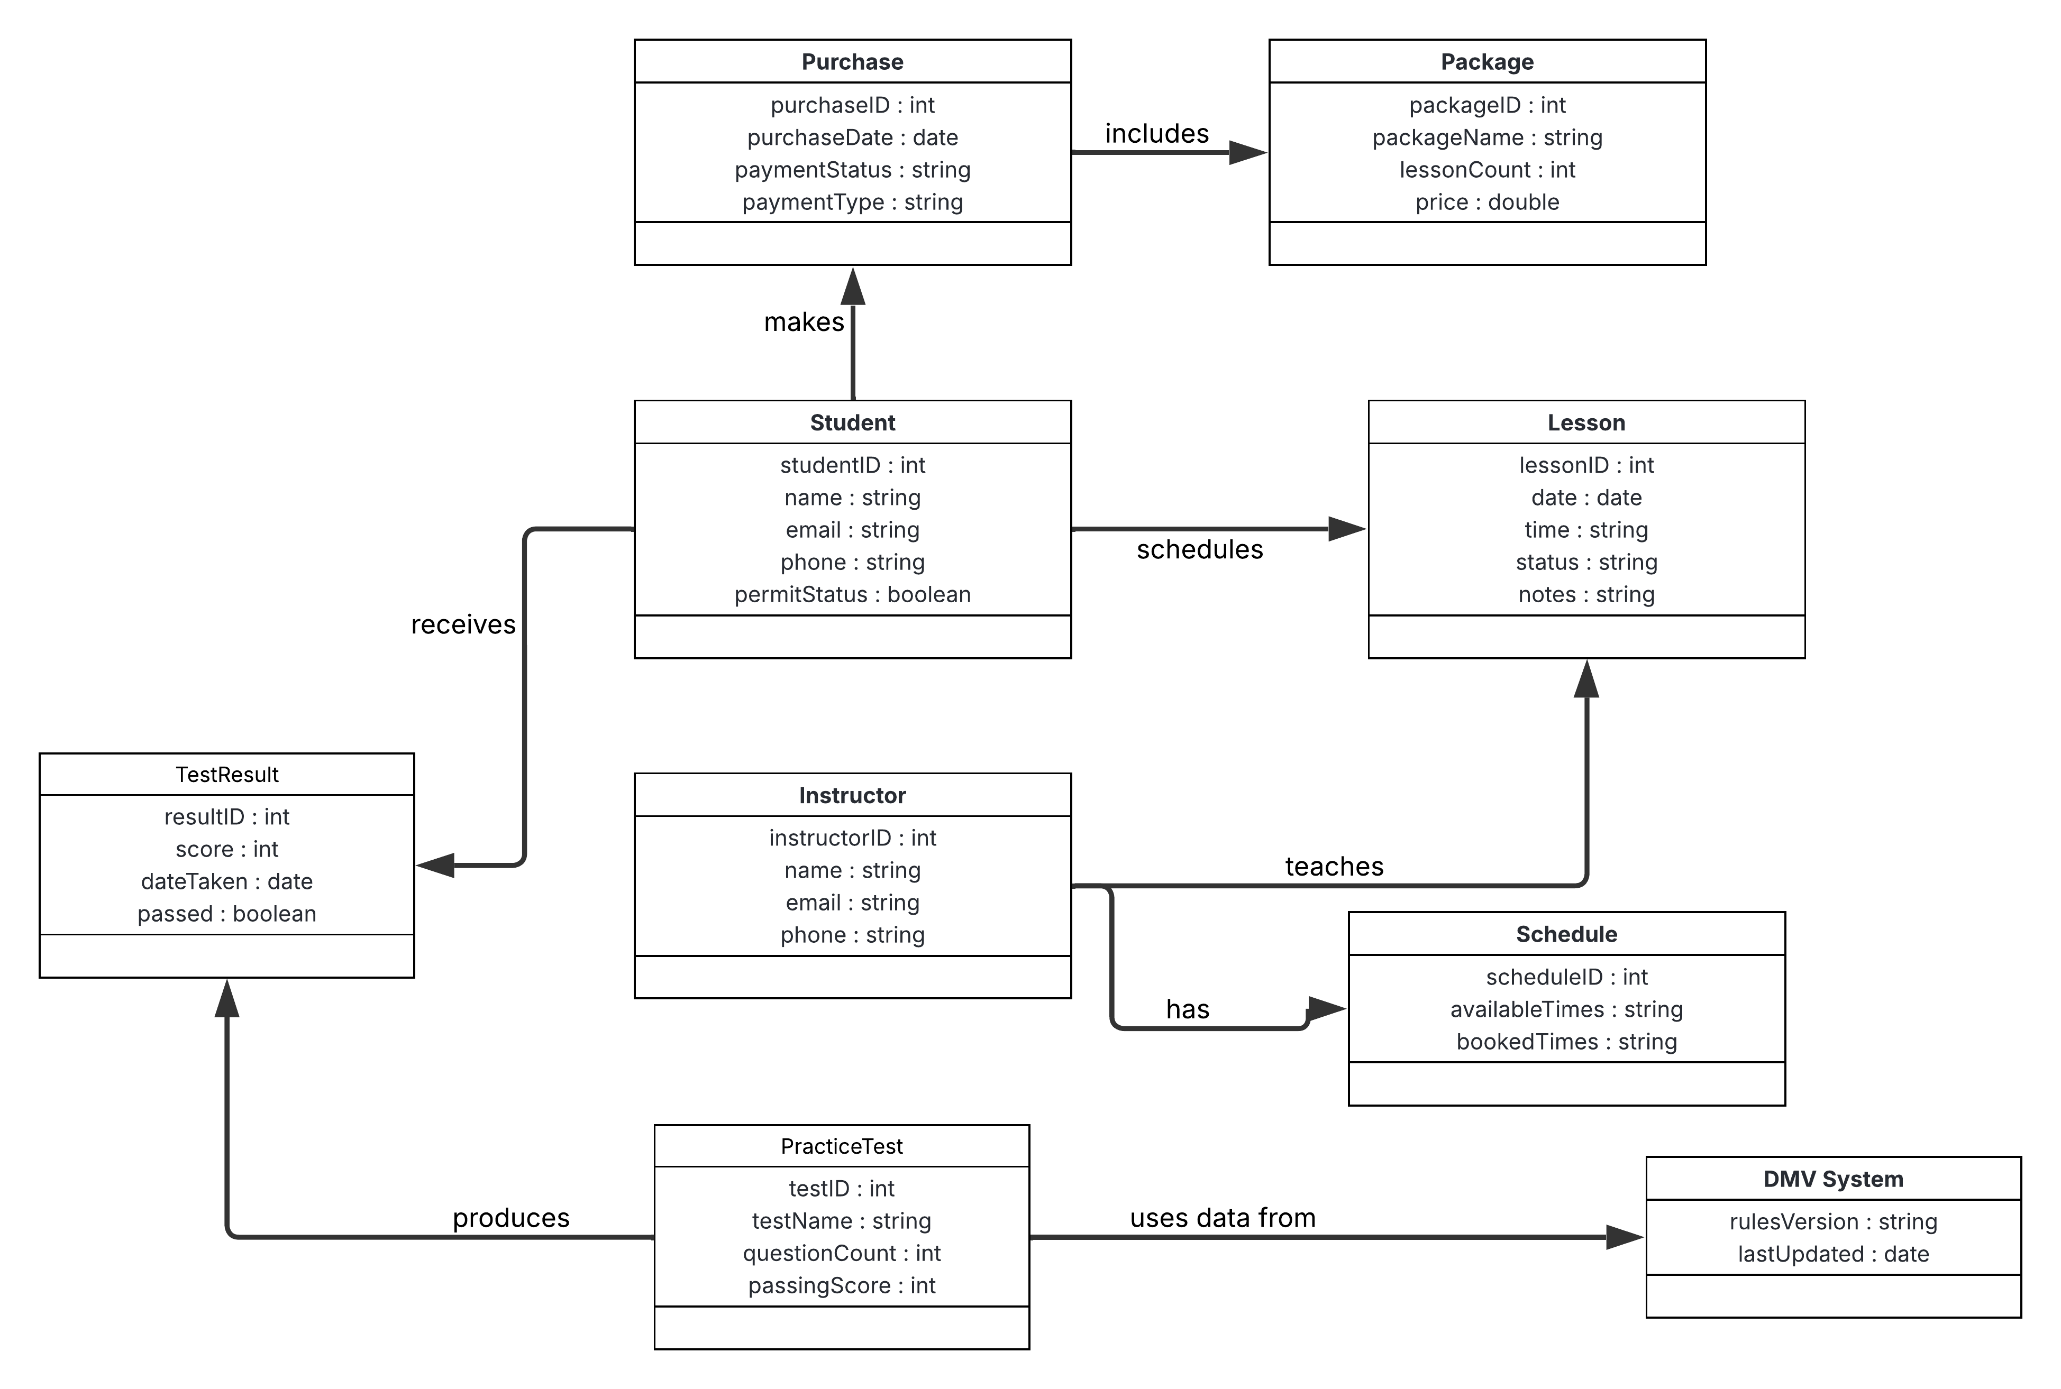

Technical Requirements
The DriverPass system requires both hardware and software components to function effectively. Users will need access to an internet connected device such as a desktop computer, laptop, tablet, or smartphone. On the software side, the system will operate through a web-based application accessible via modern web browsers. The system will require a secure database to store user accounts, lesson schedules, test results, and progress data.
From an infrastructure standpoint, the system will be hosted on a reliable server or cloud platform to ensure availability and scalability. Security measures such as user authentication, data protection, and regular backups are required to safeguard sensitive information. Development and design tools such as Lucidchart were used to create UML diagrams, and standard web technologies would be used to implement the system. These technical requirements support DriverPass’s need for a secure, reliable, and user-friendly system.

